**TASK VPC-01**

1. Create VPC with 2 private and 2 public subnets.

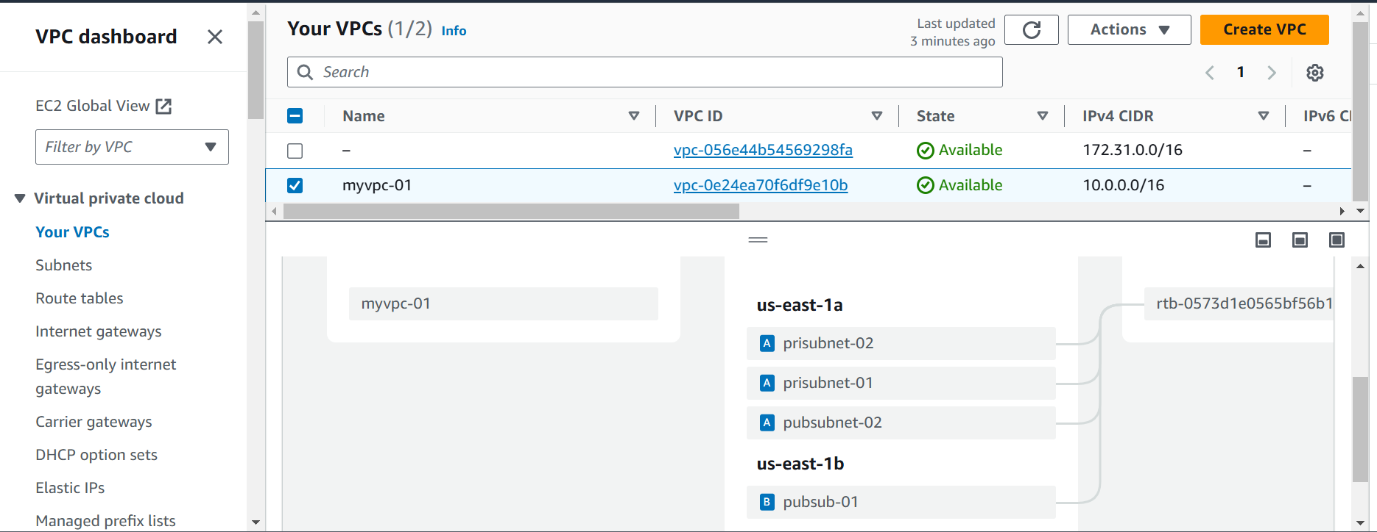

1. Enable DNS Hostname in VPC

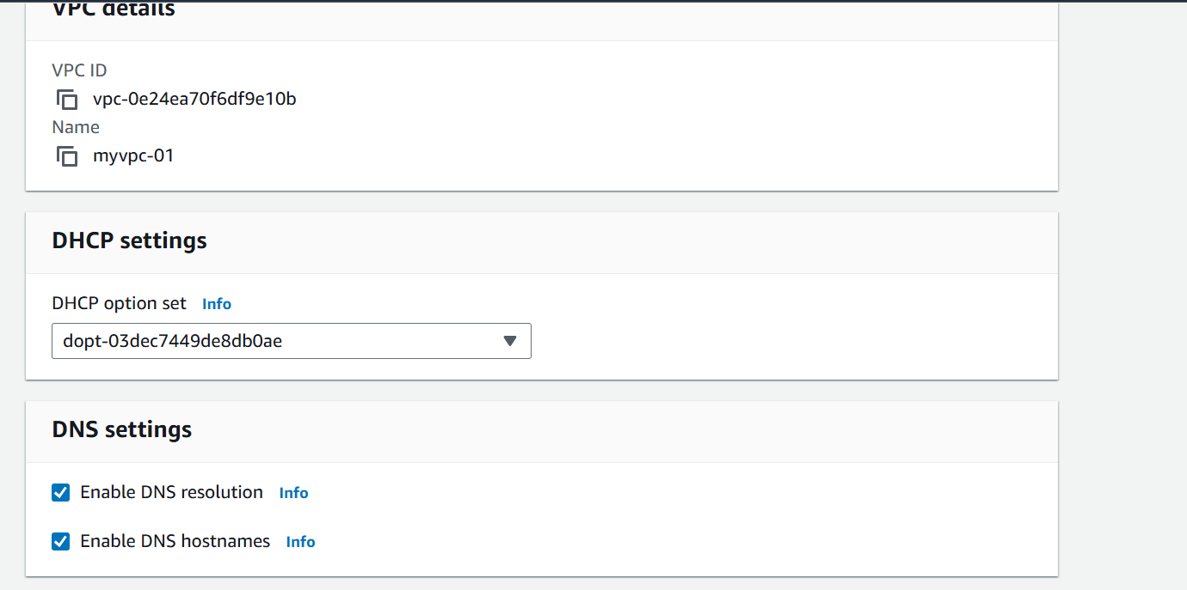

1. Enable Auto Assign Public ip in 2 public subnets

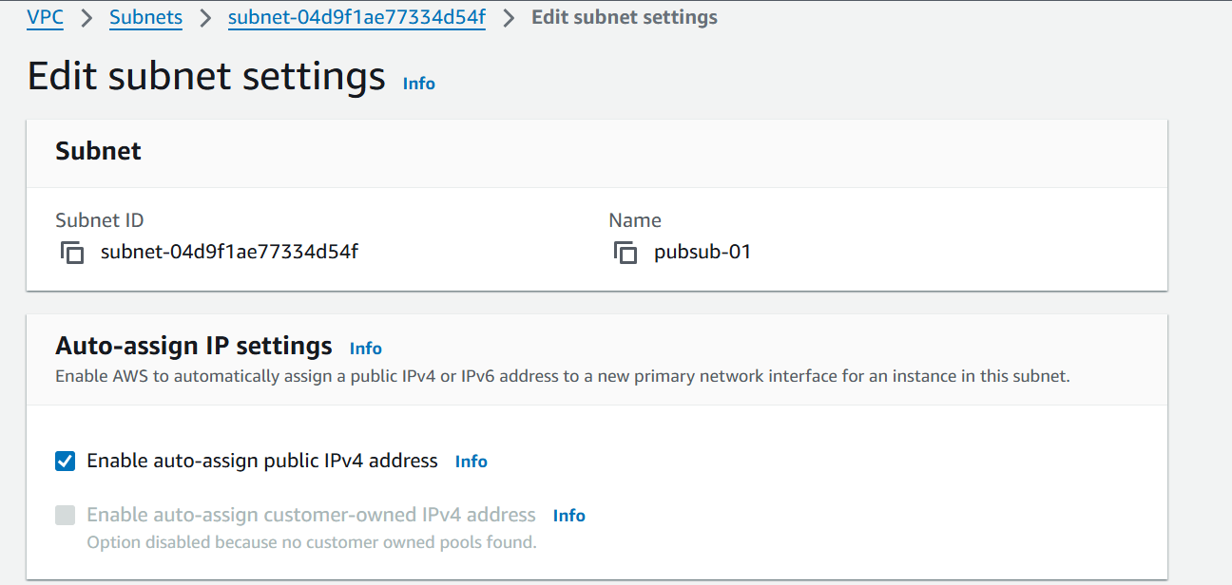

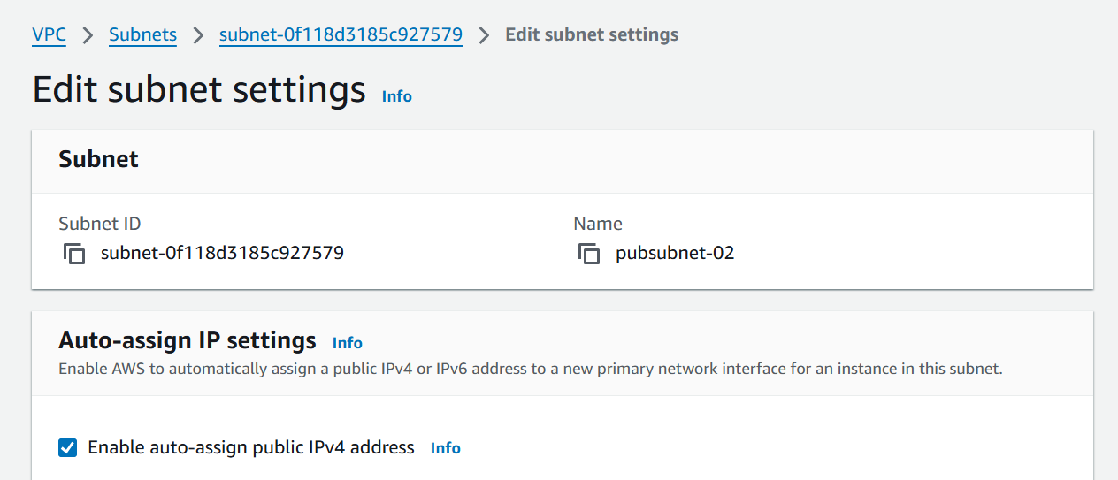

1. Add 2 private subnets in private route table

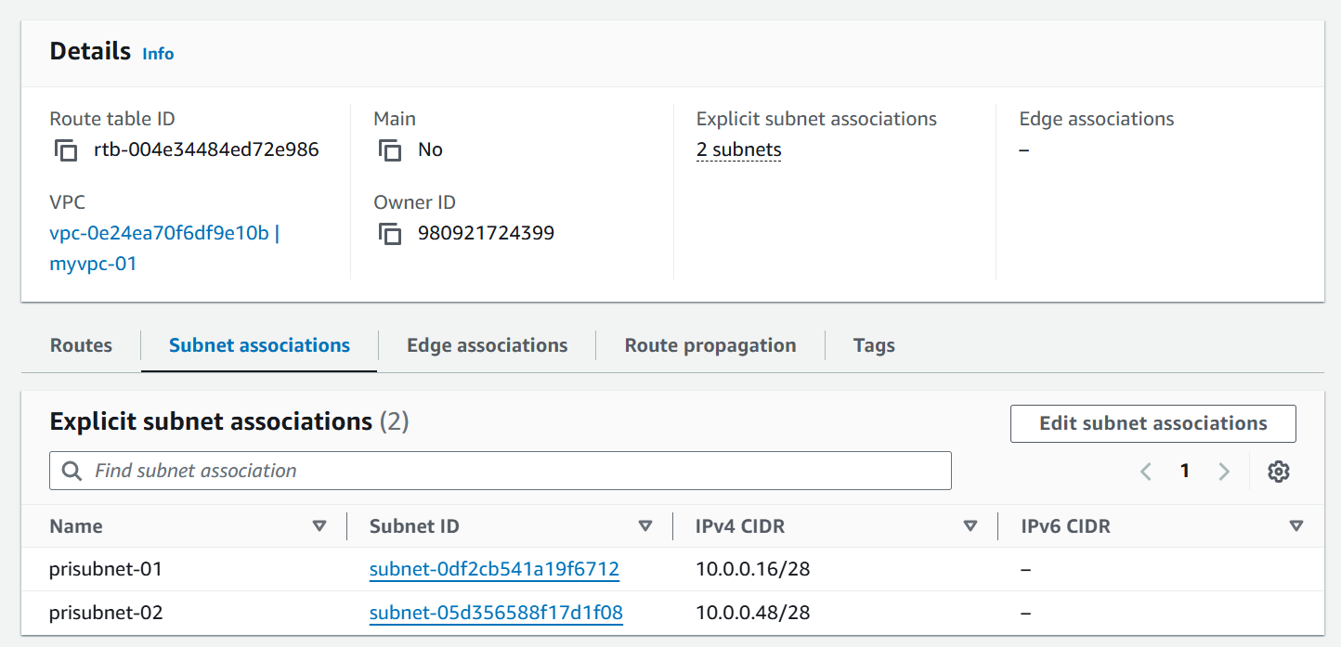

1. Add 2 public subnets in public route table

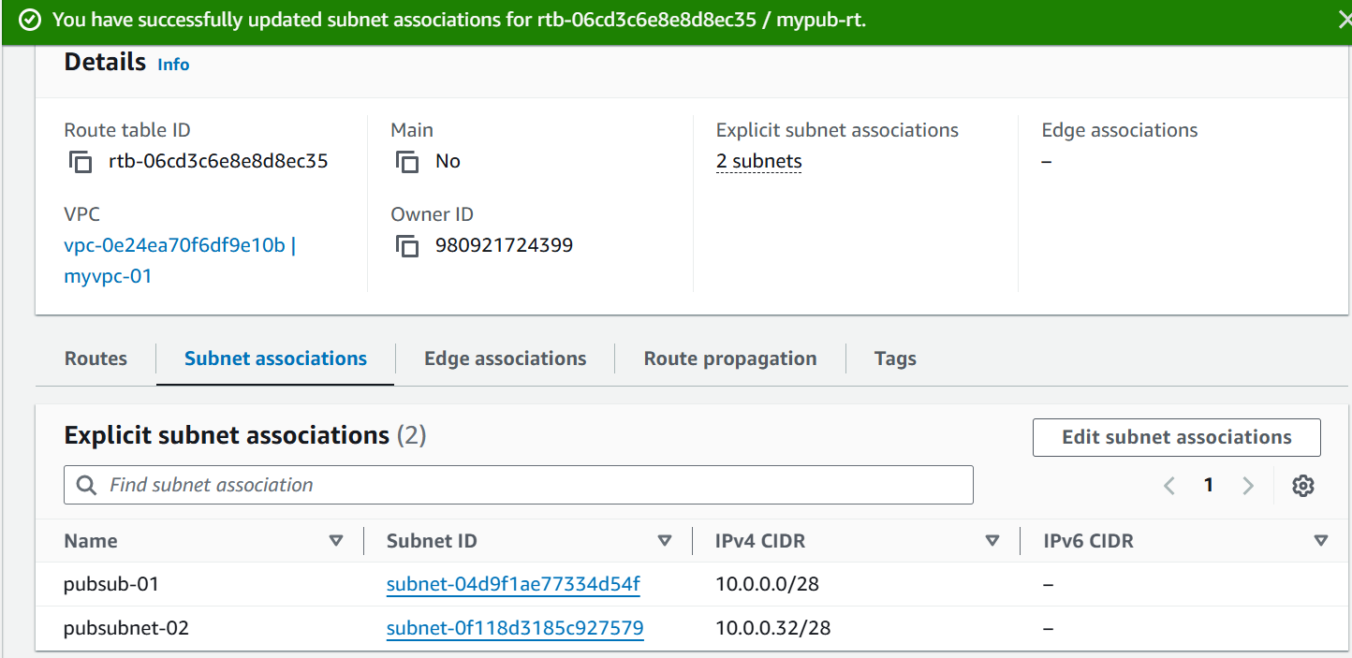

1. Public route table will have the routes to internet and local

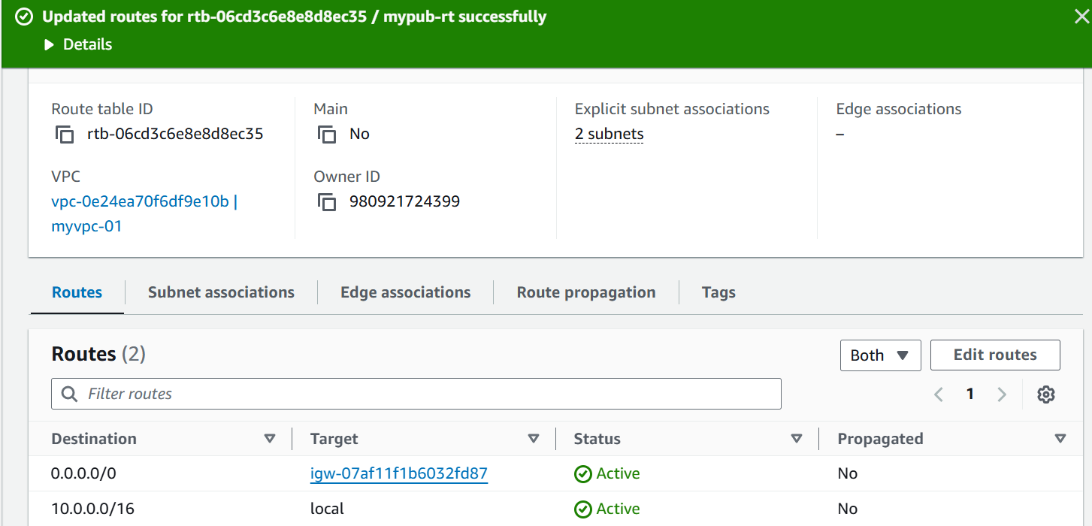

1. Create Ec2 in public subnet with t2micro and install php

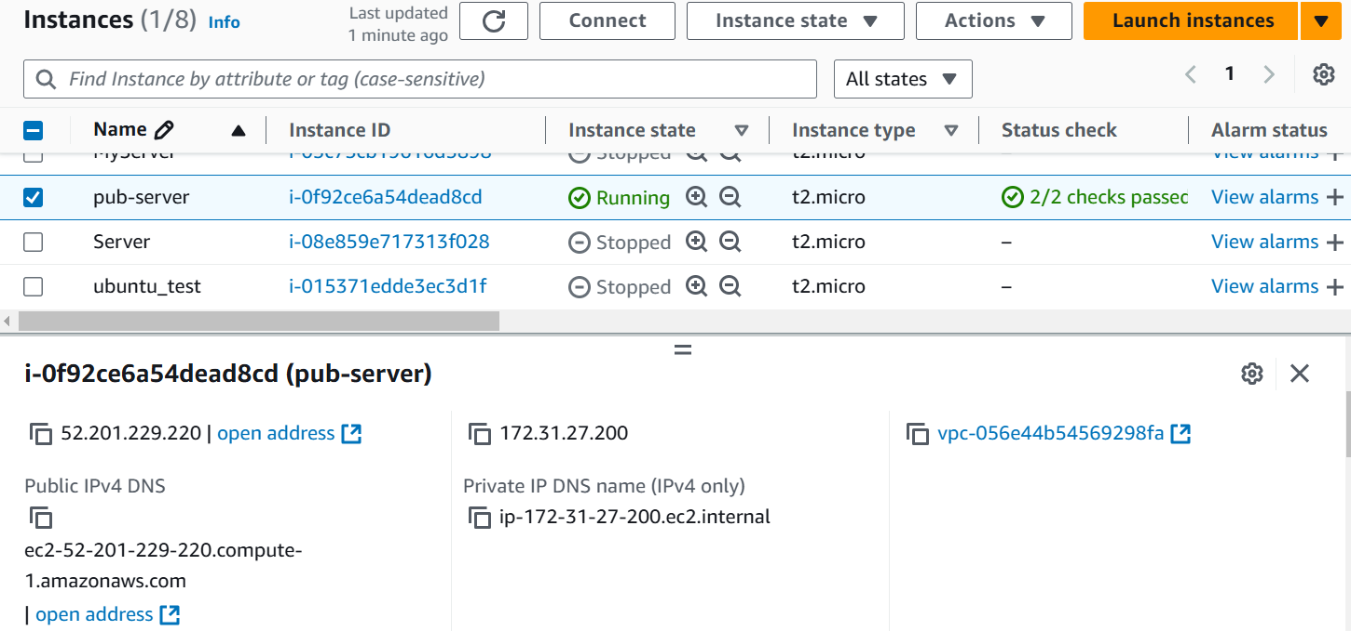

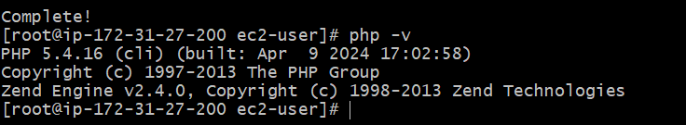

1. COnfigure Nat gateway in public subnet and connect to private Instance

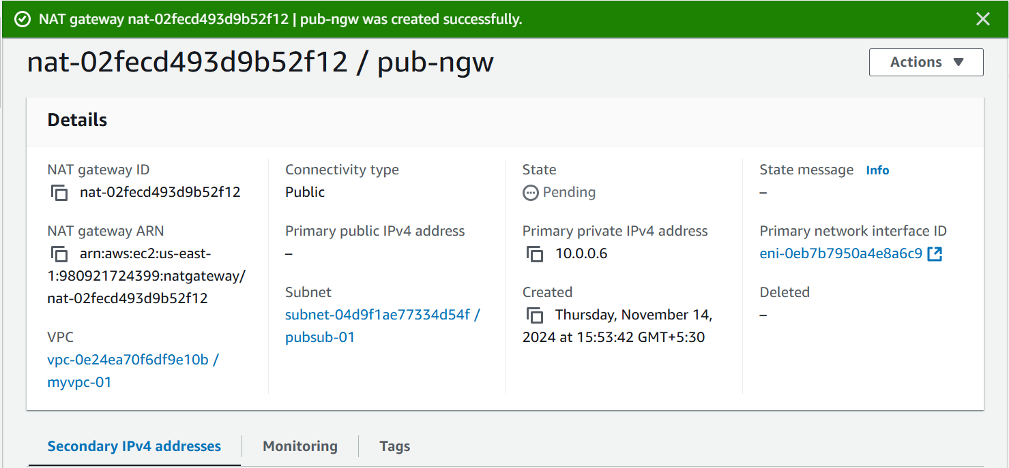

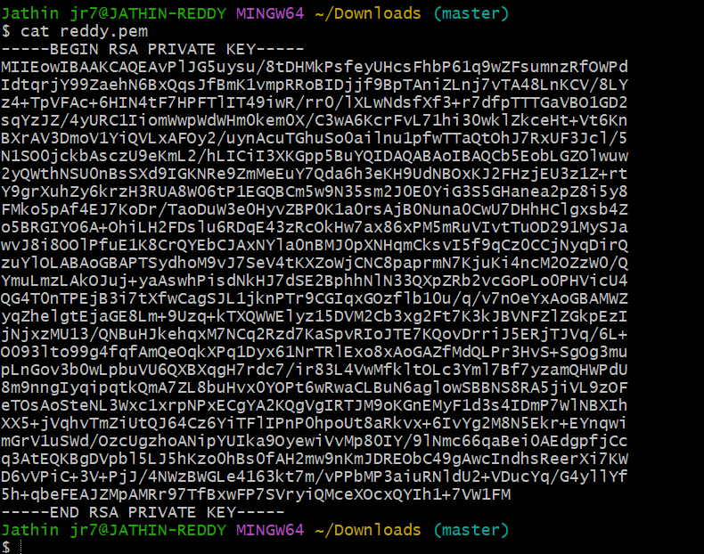

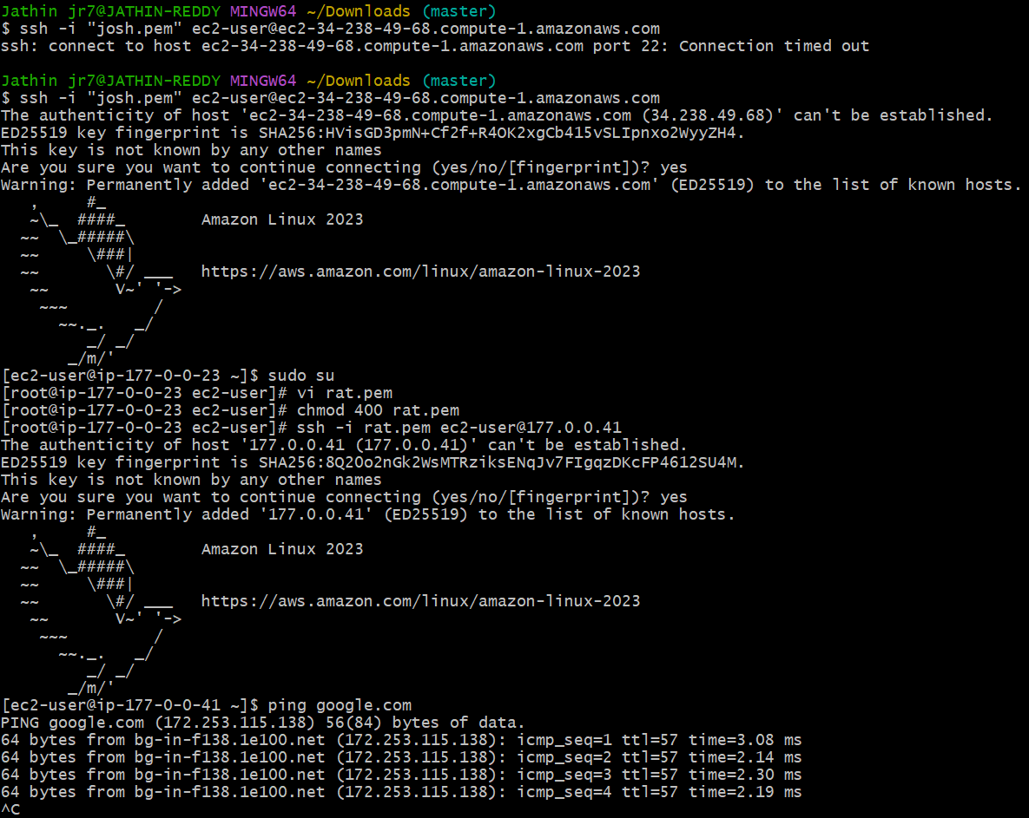

1. Install Apache Tomcat in private ec2 and deploy a sample app.

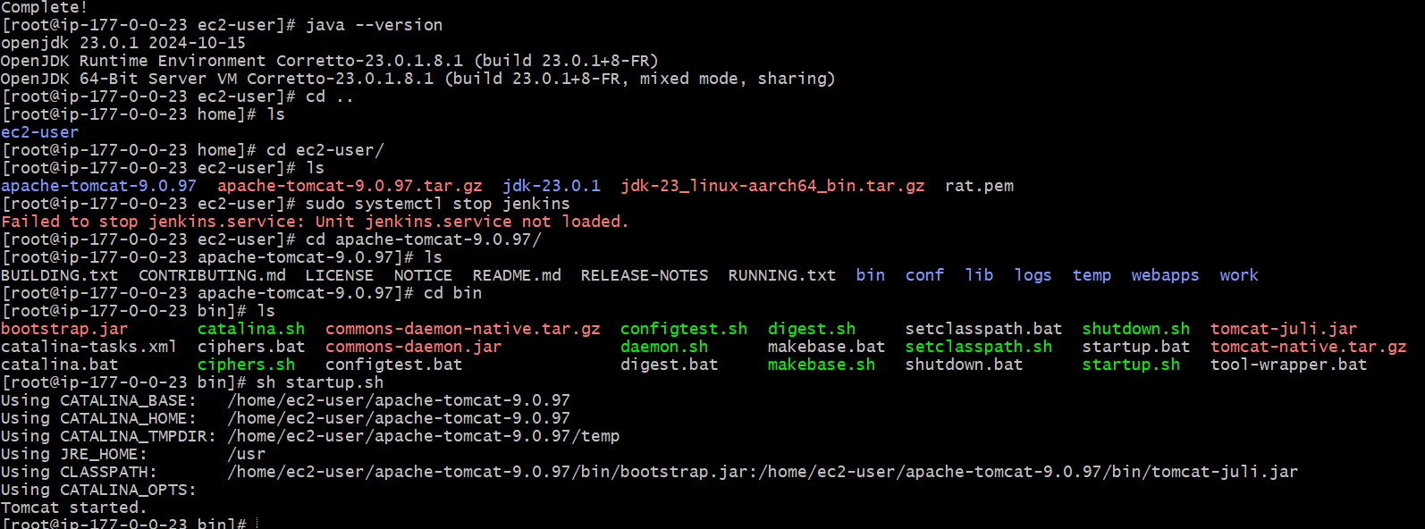

1. COnfigure VPC flow logs and store the logs in s3 and cloudwatch.

